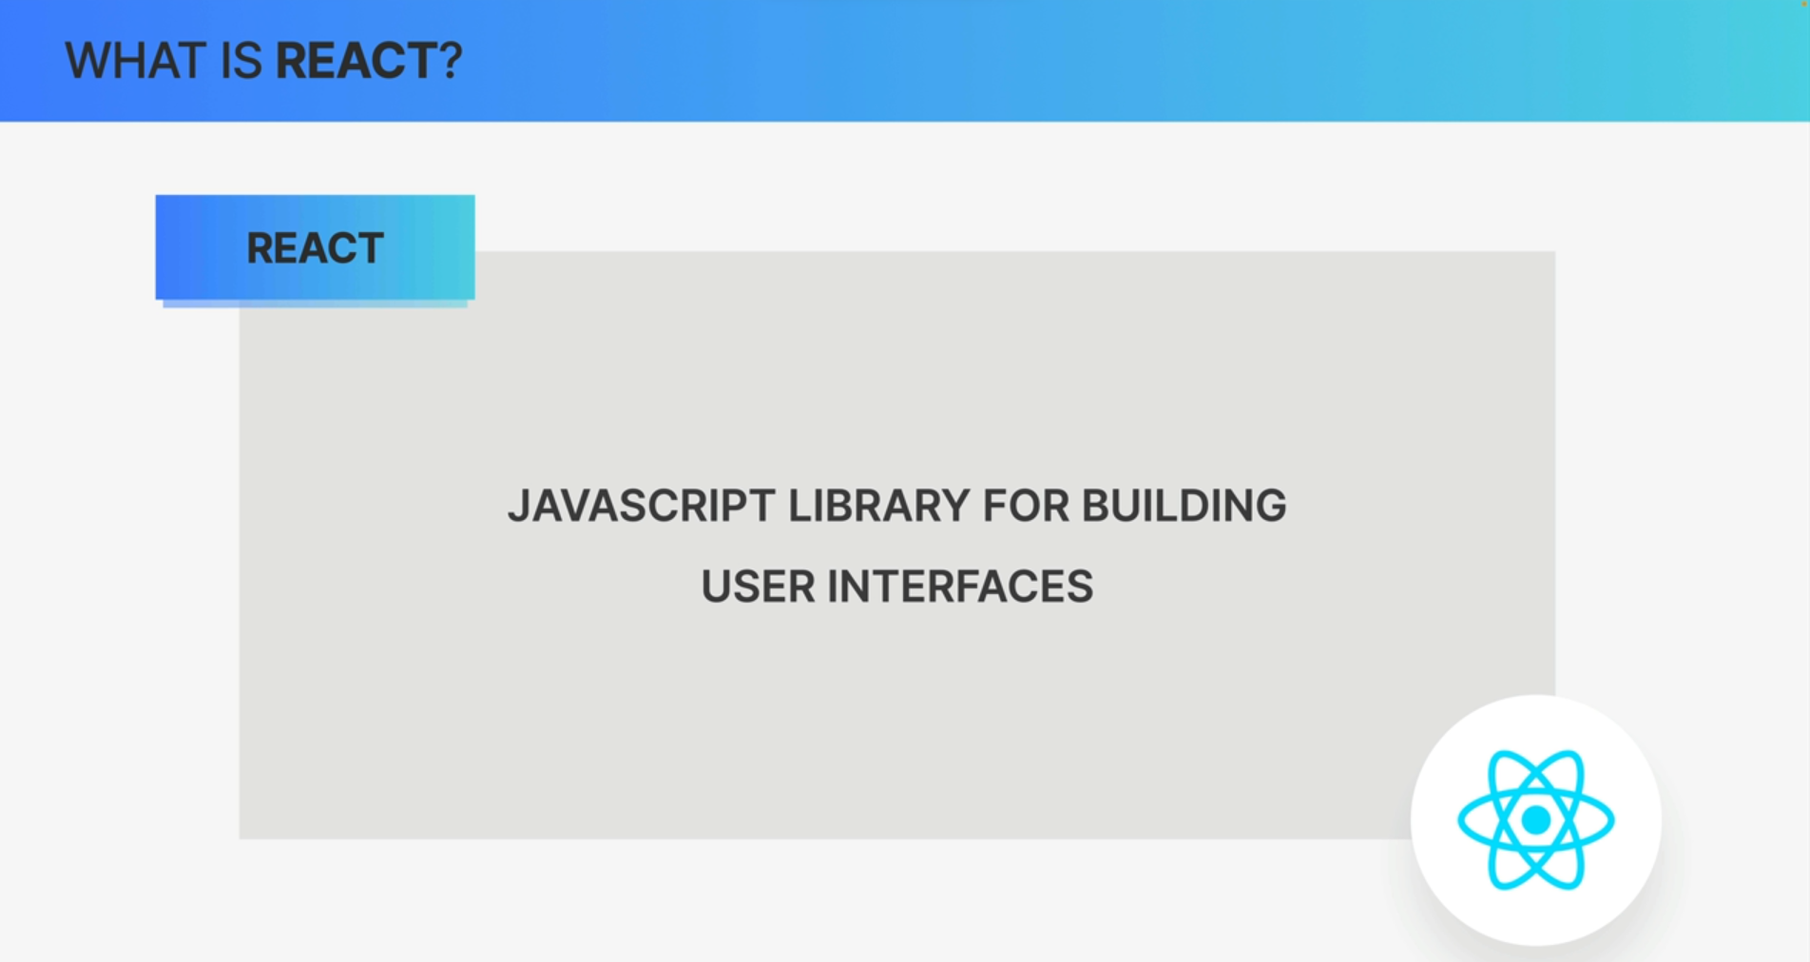

React is a JavaScript library for building user interfaces.

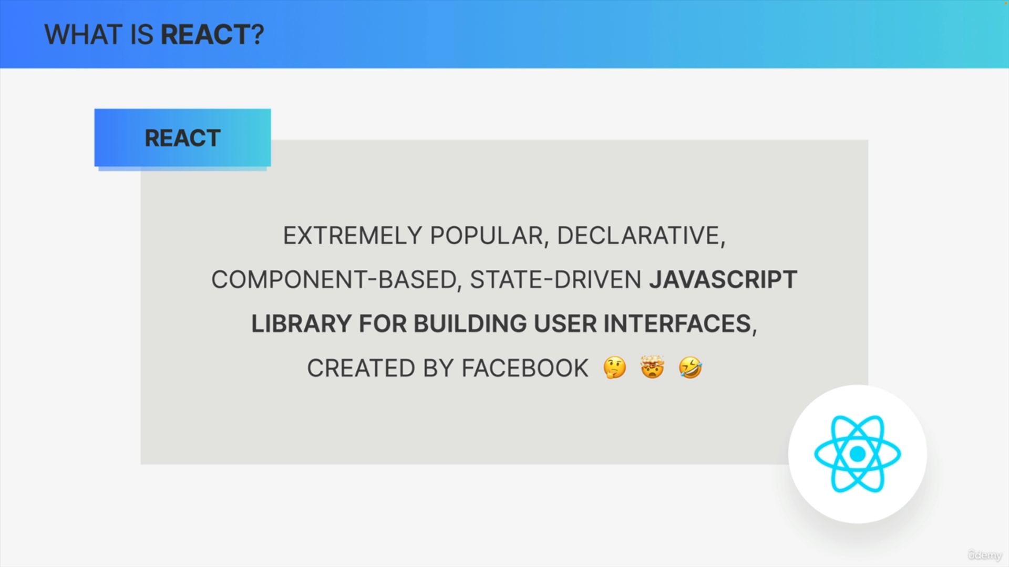

We can deconstruct this definition and learn about what React actually is, step by step.

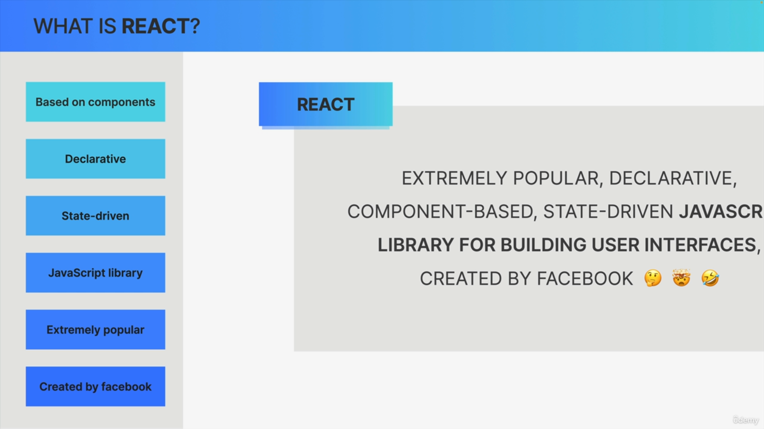

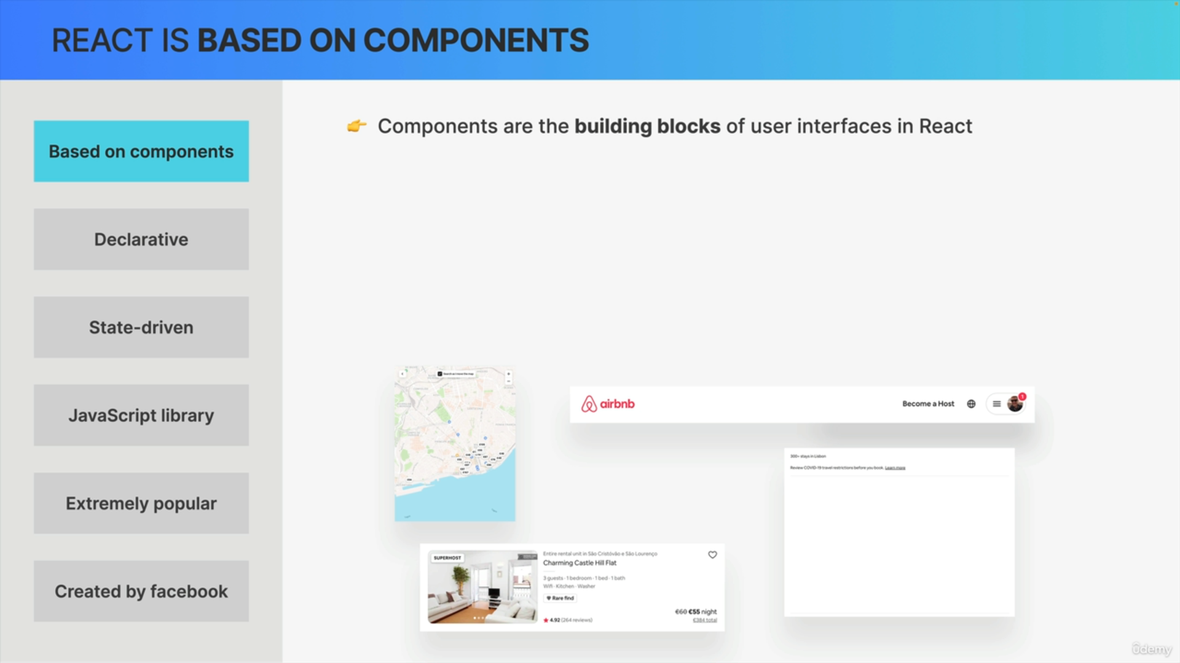

So, starting with component-based design. React is all about components such as buttons, input fields, search bars, and so on. So, components are the building blocks of user interfaces in React.

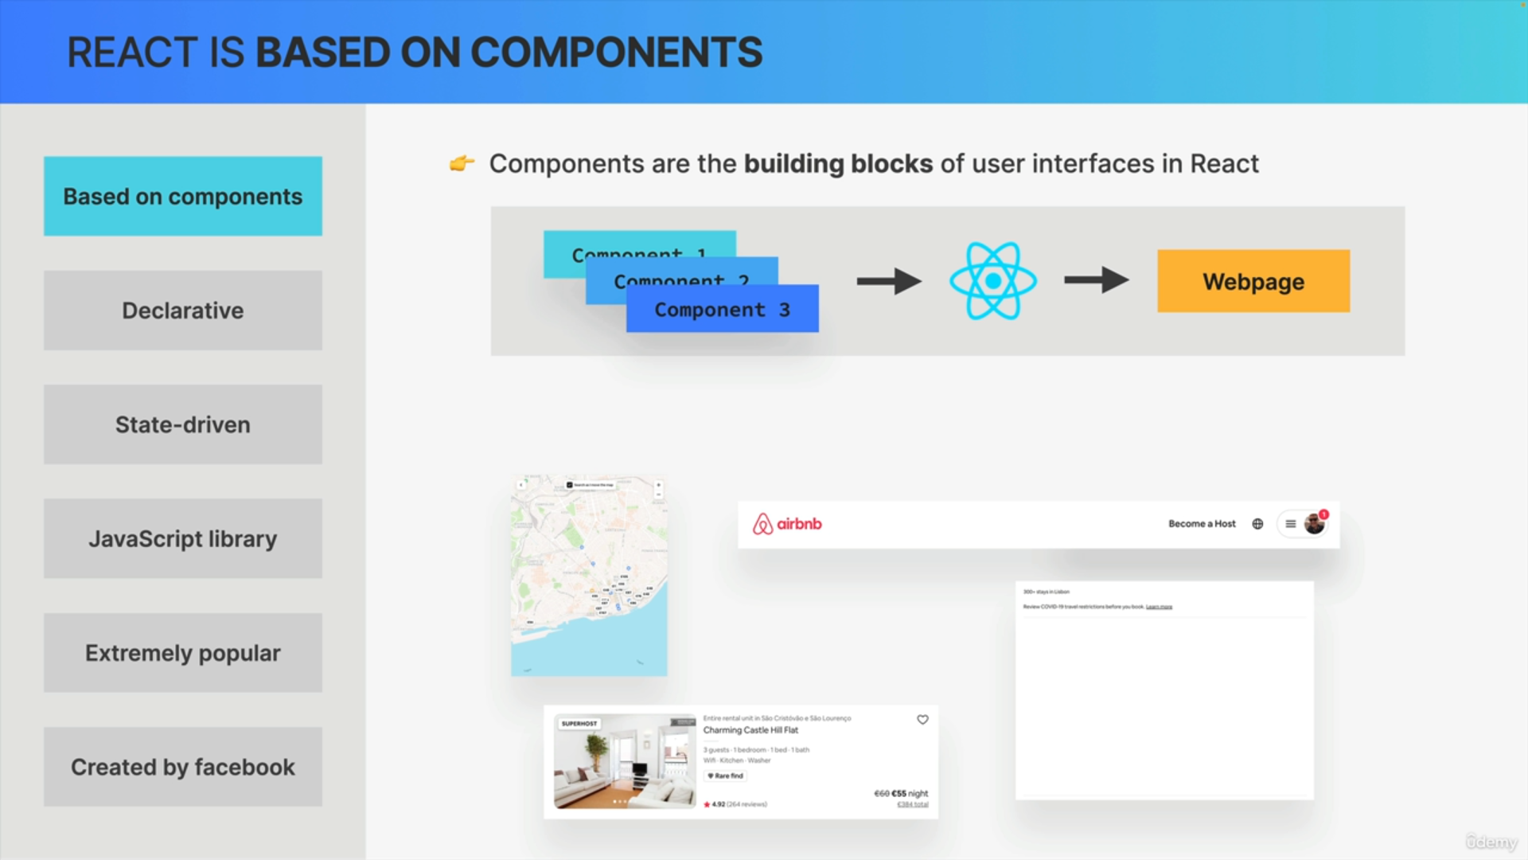

React takes all the components and draw them on a webpage.

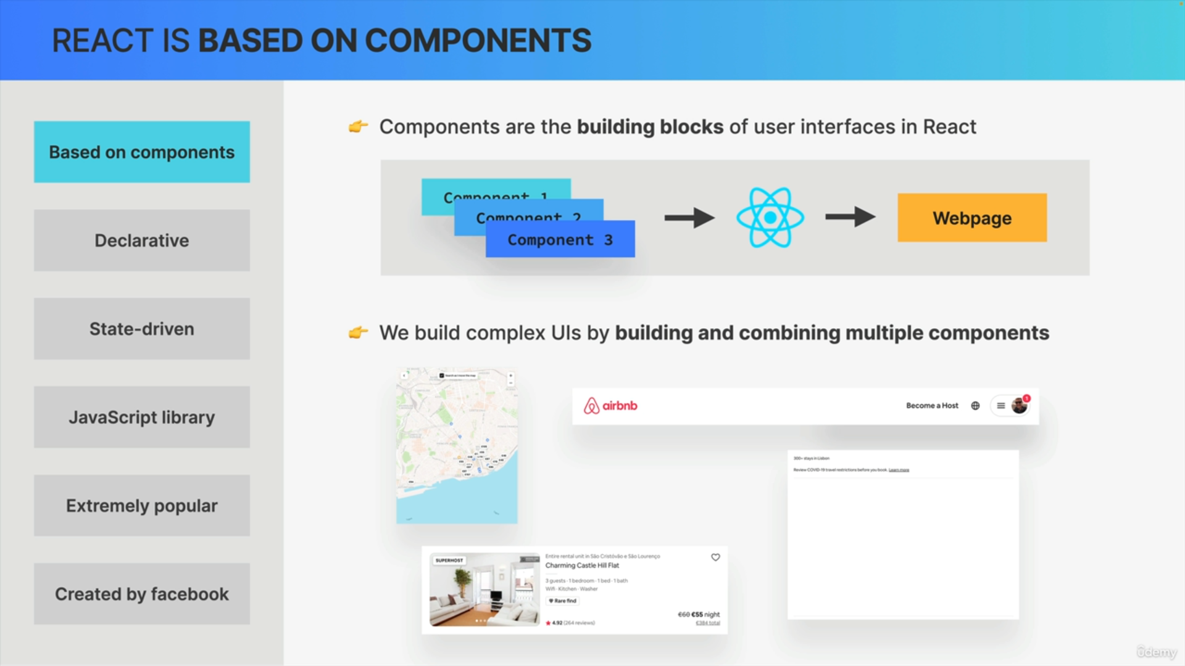

We built complex UIs in React by building multiple components and then combining these components like LEGO pieces.

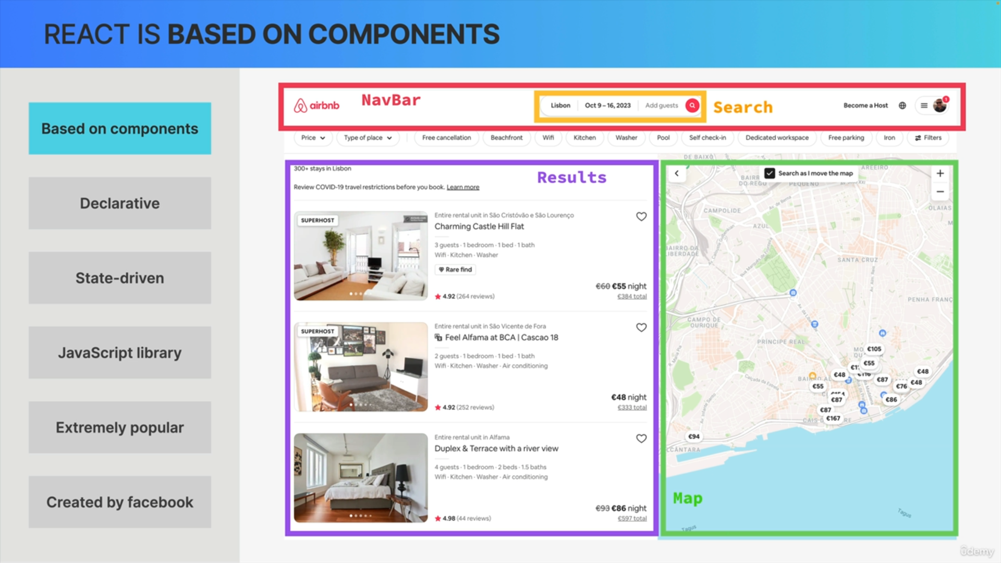

For example, to create a complex application like Airbnb. So, the navbar, the search bar, the results panel, and the map.

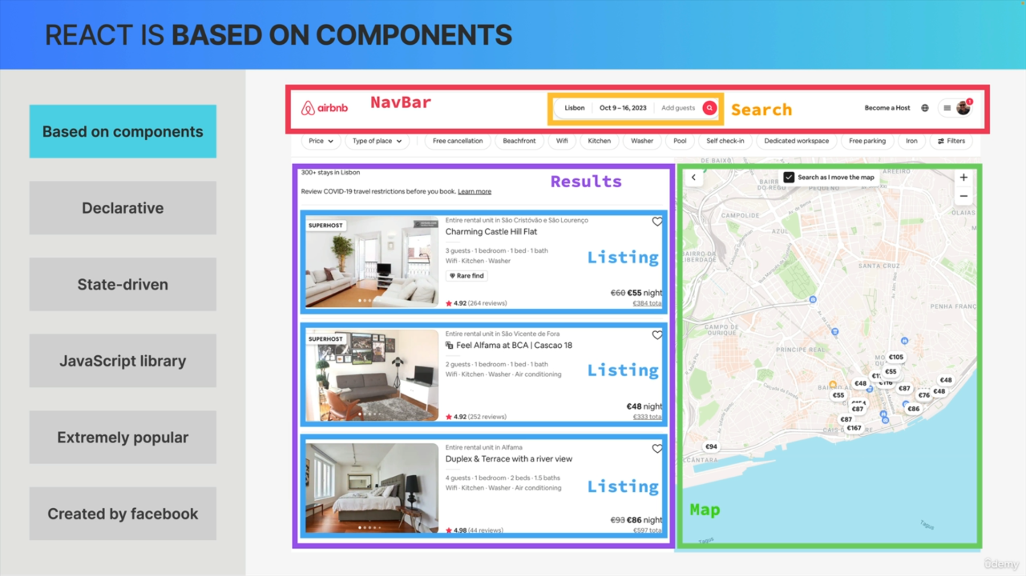

Another thing that we do with components is to reuse them. For example, here in the results panel, there are multiple listing that look quite similar. So, we can create a listing component and then reuse it three times here, simply adjusting the data a little bit.

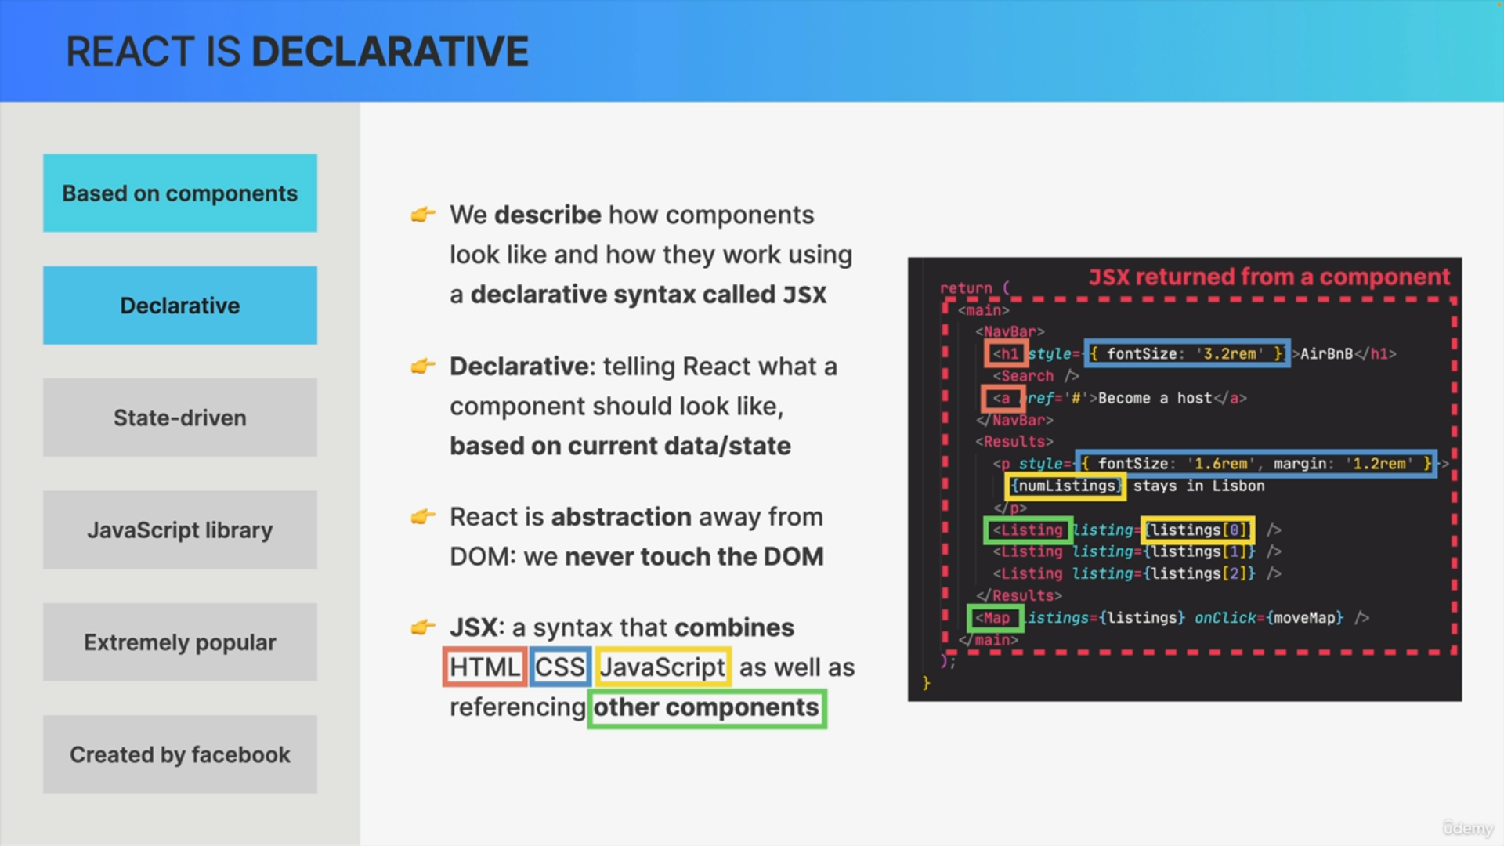

Now, since we built complex UIs by combining multiple components, each component must have all the information about what it looks like, right?

So, in order to describe what each component looks like and how it works,

we use a special declarative syntax called JSX.

Declarative simply means that we tell React what a component and ultimately the entire UI should look like based on the current state.

So, React is basically a huge abstraction away from the DOM so that we never have to work with a DOM directly as we would with vanilla JavaScript.

So, we simply tell React what we want to happen when some data changes, but not how to do it. We do that using JSX.

So, JSX is basically a syntax that combines parts of HTML, CSS, JavaScript, and it even allows us to reference other React components.

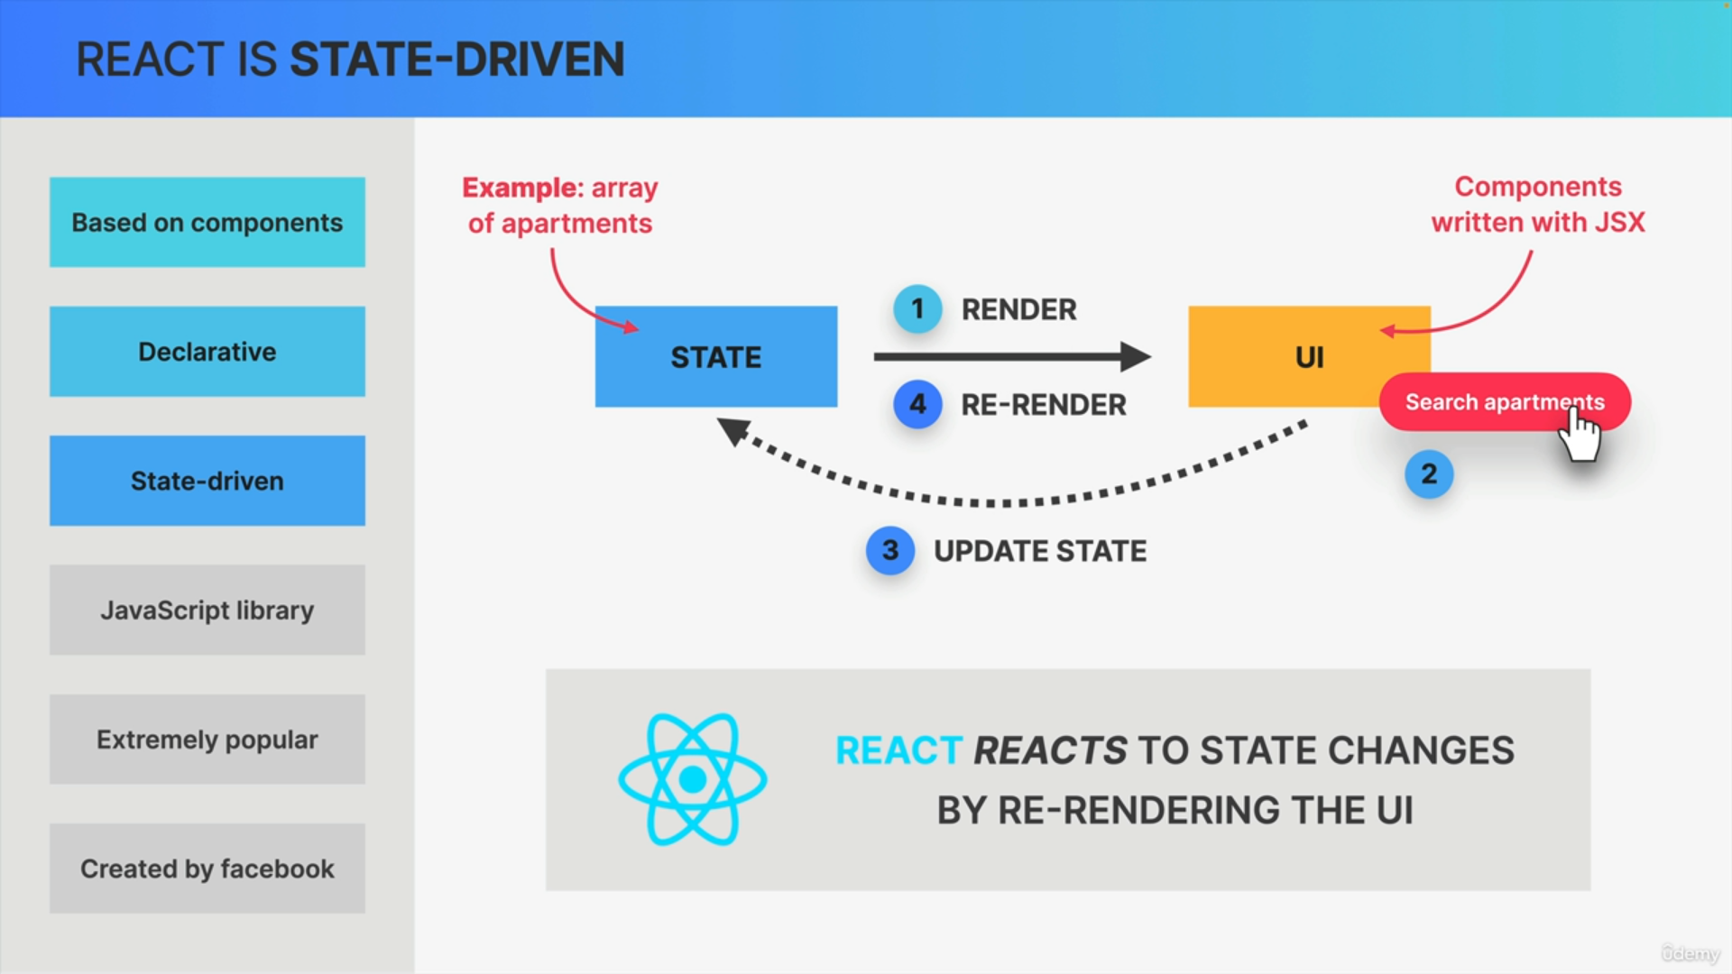

But now you might wonder, if we never touch the DOM, then how does React update the UI?

That's where the concept of state comes into play. So, remember that the main goal of React is to always keep the UI in sync with data. Let's actually call that data a state. For example, an array of apartments on Airbnb.

So, based on our initial state, React will render a user interface using the components that we wrote using JSX. Then based on some event like a button click, the state might change. For example, more data about apartments might be loaded from an API.

Whenever the state changes, we manually update the state in our app and React will then automatically re-render the user interface to reflect that latest state. In other words, React reacts to state changes by re-rendering the UI. That is in fact the whole reason why React is called React in the first place.

